From real world to exponential law. Exercises
- The number of bacteria in a certain culture doubles every hour. If there were one bacterium present in the culture originally, how many bacteria will be present at the end of one day? ___________________

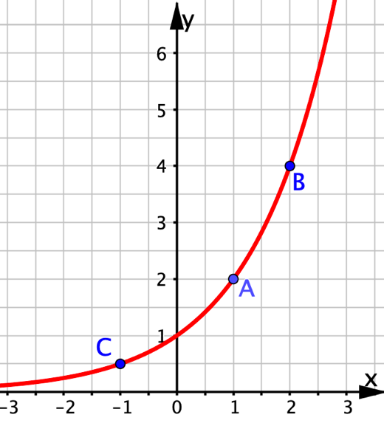
On the right is the graph of an exponential function.
- Use the grid to determine the coordinates of the points marked on the graph.
__________________________________________
- What is the equation of the graph? ____________
- For each of the following x-coordinates, find the associated y-coordinate. Give your answers exactly and do not use decimals.
x = 0 y = _____
x = − 2 y = _____
x = 1/2 y = _____
x = − 1/2 y = _____

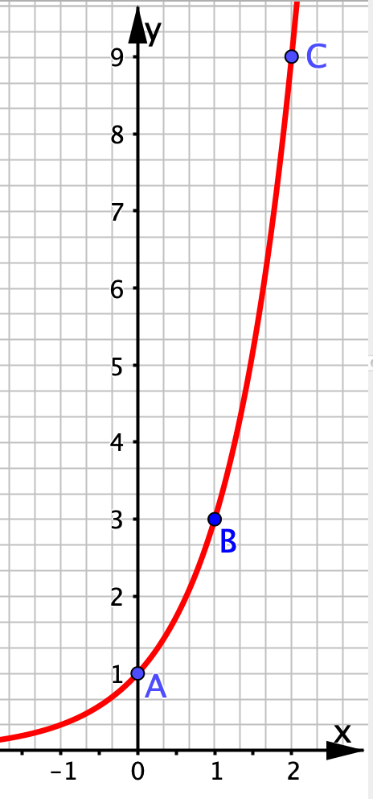
At right is the graph of an exponential function.
- Use the grid to determine the coordinates of the points marked on the graph.
_____________________________________________
- What is the equation of the graph? _______________
- For each of the following x-coordinates, find the associated y-coordinate. Give your answers exactly and do not use decimals.
x = −1 y = _____
x = − 2 y = _____
x = 1/2 y = _____
x = − 1/2 y = _____

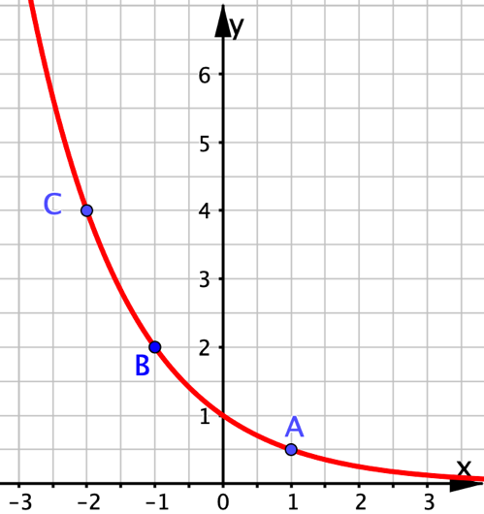
At right is the graph of an exponential function.
- Use the grid to determine the coordinates of the points marked on the graph.
__________________________________________
- What is the equation of the graph? ____________
- For each of the following x-coordinates, find the associated y-coordinate. Give your answers exactly and do not use decimals.
x = 0 y = _____
x = 2 y = _____
x = −3 y = _____
x = 1/2 y = _____

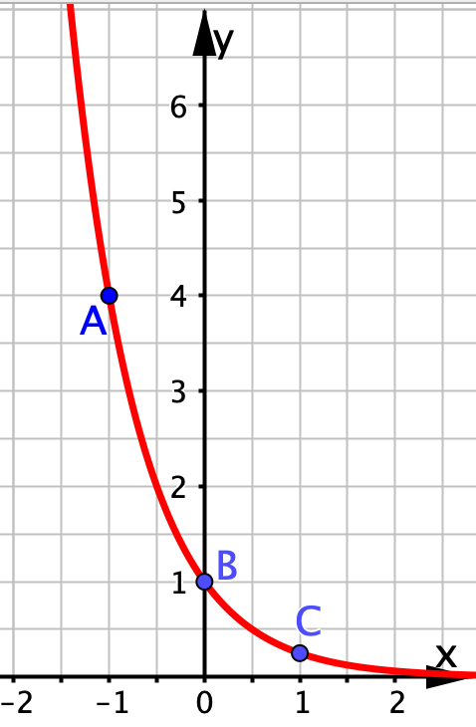
At right is the graph of an exponential function.
- Use the grid to determine the coordinates of the points marked on the graph.
_____________________________________________
- What is the equation of the graph? _____________
- For each of the following x-coordinates, find the associated y-coordinate. Give your answers exactly and do not use decimals.
x = −2 y = _____
x = 2 y = _____
x = 1/2 y = _____
x = − 1/2 y = _____

