Activity: From real world to exponential law
- Complete the following images
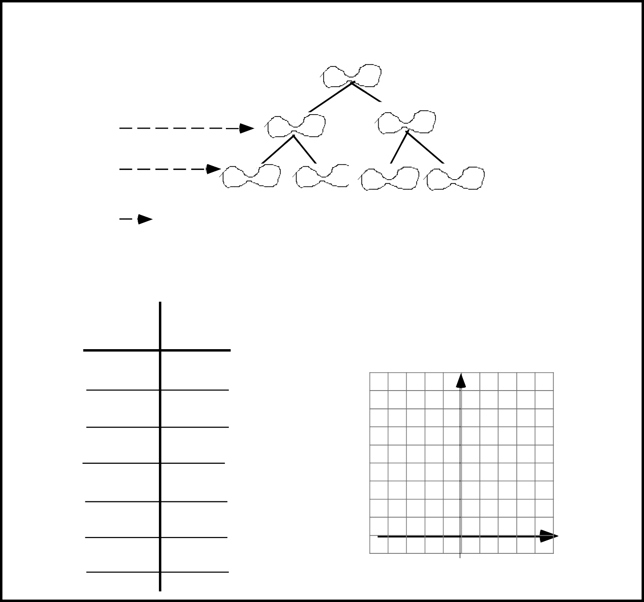
0
1
s
O 1
Law graph
Law graph

Law relating B to s: _______
3
split
2
split
1
2
3
4
10
Bacterial growth trough binary fission

split

Number of
splits
s

Number of
bacteria
B

B

- In the law relating B to s, which numbers below are permissible values for s? _______
Explain your answer.
5 –2 4,5 30 –2,5
__________________________________________________________________________________________
__________________________________________________________________________________________
- List 4 numbers that you cannot obtain in place of B with the law relating B to s.
_____________________________________________________________________________________

Daniela Valenti;
IIS “G. Vallauri”, Fossano: Liuba Ballocco, Marianna Racca, Mattia Brizio, Lorenzo Bruno

- Complete the following images
Radioactive decay of C14
After 1τ After 2τ After 3τ After 4τ

τ: half-life of C14 (Nearly 6000 years)
O 1
t

Time  t | C14 mass  M
0
1
2
3
4
10
Note: Measure time by counting the number of half-lives
Law graph
M
Law relating M to t:_________

- In the law relating M to t, can you substitute –1 for t?
Yes, and it means: _______________________________________________________
No, because ____________________________________________________________
______________________________________________________________________
- In the law relating M to t, is it possible to obtain –2 as the value of M?
Yes, and it means: ______________________________________________________
No, because ____________________________________________________________
______________________________________________________________________

Daniela Valenti;
IIS “G. Vallauri”, Fossano: Liuba Ballocco, Marianna Racca, Mattia Brizio, Lorenzo Bruno

